Service Bus: queues, worker and dead letters
  - Portal-first beginner hands-on lab
LBS | Attendee edition v2 | 26 October 2026

Before you start
Environment: use the instructor-approved sandbox, group, region, tiers and spending limit. Create only your own disposable resources. The walkthrough uses fictional data. No cloud resource is created by reading this document.
Materials: copy Labs\AppServiceSqlSample locally when the lab needs the .NET sample. Complete its setup from 02_Windows_And_Local_SQL_Setup.docx. Do not repeat resource creation if you already completed the same lab in the main guide.
Admin assistance: Contributor does not automatically grant IAM role assignment, SQL SELECT, Blob data access or Service Bus data access. Have the authorised administrator perform only the privileged step. Never bypass policy.
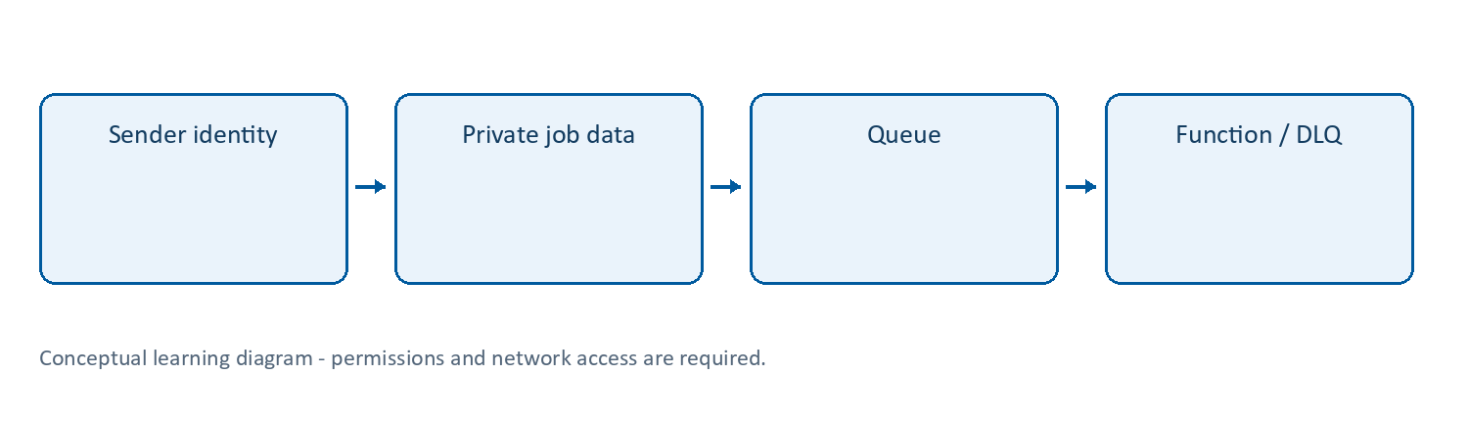
Learning flow

Service Bus | Reliable asynchronous messages
What: a managed message broker. A namespace contains queues and, on supporting tiers, topics/subscriptions. A queue normally delivers work to competing consumers; a topic enables independent subscriptions to receive matching messages.
Why/when: decouple components, absorb bursts and retry transient failures without making callers wait for the whole process. A broker is not the authoritative record of completed business processing.
How: create namespace/queue, grant Sender and Receiver data roles, send a message with the SDK, run a trigger/consumer, inspect retries and the dead-letter queue. Follow Lab 11.
Example: after storing a document, a publisher sends its ID and blob name to the applications queue. A Function consumes that job.
Tips and traps: use the modern Azure.Messaging.ServiceBus library. Peek does not remove messages; receive/settlement can. Messages may be delivered again; make business effects idempotent. A DLQ needs monitoring and an approved replay process, not infinite retries. Never place large files or customer secrets in message bodies when a protected reference is sufficient.
Reference: https://learn.microsoft.com/azure/service-bus-messaging/service-bus-messaging-overview

Lab 11 | Service Bus queue and Function worker (extension)
Time: 45-60 minutes. Needs: Lab 10, data-role administrator assistance and Azure CLI sign-in. Cost: Service Bus namespace and Function execution.

11A. Create messaging resources in the portal
- Create a Service Bus namespace named sb-lbs-<suffix> in the approved region/group.
- For a queue-only lab choose instructor-approved Basic, or Standard if the instructor will demonstrate topics/subscriptions or other Standard features. Do not choose Premium by default.
- Create a queue named applications. For this disposable exercise, set max delivery count to 3; retain sensible lock/TTL defaults. Do not enable sessions for this example.
- On namespace Access control (IAM), have an authorised administrator assign:
  - your developer identity: Azure Service Bus Data Sender for the console producer;
  - your developer identity: Azure Service Bus Data Receiver only if testing the worker locally;
  - the Function App’s system-assigned identity: Azure Service Bus Data Receiver.
- Use namespace scope for this trigger exercise, including required runtime metadata access. Do not substitute Contributor or RootManageSharedAccessKey. Wait for propagation.

11B. Configure an identity-based trigger
In LbsFunctions, add the supported Service Bus isolated-worker extension (5.x or later):
dotnet add package Microsoft.Azure.Functions.Worker.Extensions.ServiceBus
Add ApplicationWorker.cs with this complete example. The namespace is independent of the generated HTTP function:
using Microsoft.Azure.Functions.Worker;
using Microsoft.Extensions.Logging;
namespace LbsFunctions;
public sealed class ApplicationWorker
{
private readonly ILogger<ApplicationWorker> _logger;
public ApplicationWorker(ILogger<ApplicationWorker> logger)
{
_logger = logger;
}
[Function(nameof(ApplicationWorker))]
public void Run(
[ServiceBusTrigger("applications", Connection = "ServiceBus")]
string message)
{
if (string.Equals(message, "FAIL", StringComparison.Ordinal))
{
throw new InvalidOperationException(
"Deliberate LBS lab failure.");
}
_logger.LogInformation(
"Processed fictional training message; length {Length}",
message.Length);
}
}
For local worker testing, add the following entry inside the existing Values object in local.settings.json, preserving its generated settings:
"ServiceBus__fullyQualifiedNamespace": "<actual-namespace>.servicebus.windows.net"
Sign in with az login as the developer granted Receiver access. Keep local credential selection at its developer default; do not set credential=managedidentity locally.
In the Azure Function App’s Environment variables, add:
ServiceBus__fullyQualifiedNamespace = <actual-namespace>.servicebus.windows.net
ServiceBus__credential = managedidentity
The Connection = "ServiceBus" prefix matches these settings. Do not also set a ServiceBus connection string, which would change connection resolution. Host storage settings remain required and separate.
Build and redeploy the Functions project. For a deterministic cloud test, stop the local Functions host first: two active receivers compete for messages from the same queue.

11C. Send a message from .NET
Create a separate LbsSender console project outside the Functions and web project folders:
dotnet new console -n LbsSender --framework net10.0
Set-Location .\LbsSender
dotnet add package Azure.Messaging.ServiceBus
dotnet add package Azure.Identity
Replace its Program.cs with:
using Azure.Identity;
using Azure.Messaging.ServiceBus;
var host = Environment.GetEnvironmentVariable("LBS_SERVICEBUS_HOST")
?? throw new InvalidOperationException(
"Set LBS_SERVICEBUS_HOST to the namespace FQDN.");
await using var client = new ServiceBusClient(
host, new DefaultAzureCredential());
await using var sender = client.CreateSender("applications");
var body = args.Length == 0 ? "LBS fictional application 001" : args[0];
var message = new ServiceBusMessage(body)
{
MessageId = Guid.NewGuid().ToString("N")
};
await sender.SendMessageAsync(message);
Console.WriteLine($"Sent message {message.MessageId}");
Then run:
az login
$env:LBS_SERVICEBUS_HOST = "<actual-namespace>.servicebus.windows.net"
dotnet run
Use the FQDN only, without https:// or sb://. DefaultAzureCredential uses an available developer credential; if it selects the wrong account, review the credential sources and tenant with the instructor.

11D. Verify retries and dead-lettering
- In the queue’s Service Bus Explorer, use Entra authentication and Peek to inspect messages if your data role permits it. Peek does not consume a message; Receive/Delete can.
- With only the cloud worker active, the normal message should be processed and leave the active queue. Confirm a successful invocation, not only a zero queue count.
- Send the deliberate failure:
dotnet run -- FAIL
- The worker throws, the message is retried, and after max-delivery handling it should appear in the dead-letter subqueue. Allow processing time; exact delivery timing is not guaranteed.
- Inspect its dead-letter reason with appropriate Receiver access. Fixing a consumer does not automatically replay existing dead-letter messages. Do not build an infinite replay loop.
- Explain at-least-once delivery: production handlers need idempotency; successful settlement is not a guarantee of exactly-once business processing.
Checkpoint: one successful message, one observed failure/retry sequence, and a dead-letter observation. If RBAC/network access blocks execution, record that blocker instead of using a shared administrator connection string.

Completion record and cleanup
Record | Your observation
Subscription/group/region and actual resource names
Expected result and actual result
Log/table/metric, time range and evidence
Identity, role/scope and network restrictions
Idle/usage/logging cost driver
Cleanup or retention owner/deadline
Only mark a lab passed after its functional checkpoint. A deployment success or empty error table alone is not proof. Mark blocked permissions honestly.
Clean up only your own disposable objects; removing a diagnostic setting does not erase retained logs, and stopping an app does not stop every cost. Follow Lab 13 in the main guide. Keep secrets/customer information out of evidence.
Verification scope: these instructions and Word file structure were reviewed. Automated Word pagination could not be completed; preview before printing. Azure execution, prices, policy, permissions, plan/runtime availability and portal labels require instructor rehearsal in the actual training subscription.

